Southwest University
School of Computer & Information Science
Database Principles and Applications
Course Design Report

Coffee Shop Order Management System

Author : 114 Yang Fan
Major : Computer Science and Technology, Class of 2024
Course : Database Principles and Applications
Date : May 2026

1. Division of Labor
This course design is completed independently by 114 Yang Fan. All work, including requirement analysis, database design, application implementation, testing, and report writing, is undertaken by the author.
Member | Student ID | Responsibility
Yang Fan | xxx114 | Requirements, ER design, schema (DDL/DML), Flask backend, front-end templates, testing, report
2. Overview
The Coffee Shop Order Management System (OMS) is a small but complete business information system aimed at digitising the daily operations of an independent coffee shop. The main tasks tackled by this project are:
- Building a relational schema that fully describes the data of a coffee shop (customers, staff, menu, orders, inventory, promotions).
- Implementing referential integrity, business rules, indexes, views, triggers and a stored procedure inside the database itself, so that the data layer remains consistent regardless of which client manipulates it.
- Providing a browser-based application with role-based access for Admin / Barista / Cashier that supports CRUD on every entity and exposes daily-revenue and best-seller statistics.
- Demonstrating how the application interacts with the database through an ORM, while the underlying SQL still leverages classical DBMS features.
The main problems to be solved include: (1) modelling a one-to-many / many-to-many domain without redundancy and with proper normalisation; (2) keeping order totals consistent when order items change; (3) awarding member-loyalty points automatically when an order is paid; (4) preventing over-selling by tracking ingredient inventory and warning the operator when stocks fall below thresholds.
3. Database Design and SQL Statements
3.1 Requirement analysis. Through interviews with the owner of a campus coffee shop, the following data flows were identified: a cashier creates an order on behalf of a (possibly anonymous walk-in) customer; the order consists of one or more items, each linked to a menu product; the order transitions through PENDING -> PAID -> PREPARING -> READY -> COMPLETED, or it can be CANCELLED; once paid, the customer earns one loyalty point per RMB spent; products consume ingredients tracked in the inventory.
3.2 Conceptual design (ER model). The entities identified are: Customer, Staff, Category, Product, Order, OrderItem, Inventory, Promotion, and the associative entity ProductIngredient. The ER diagram is shown below (Figure 1).
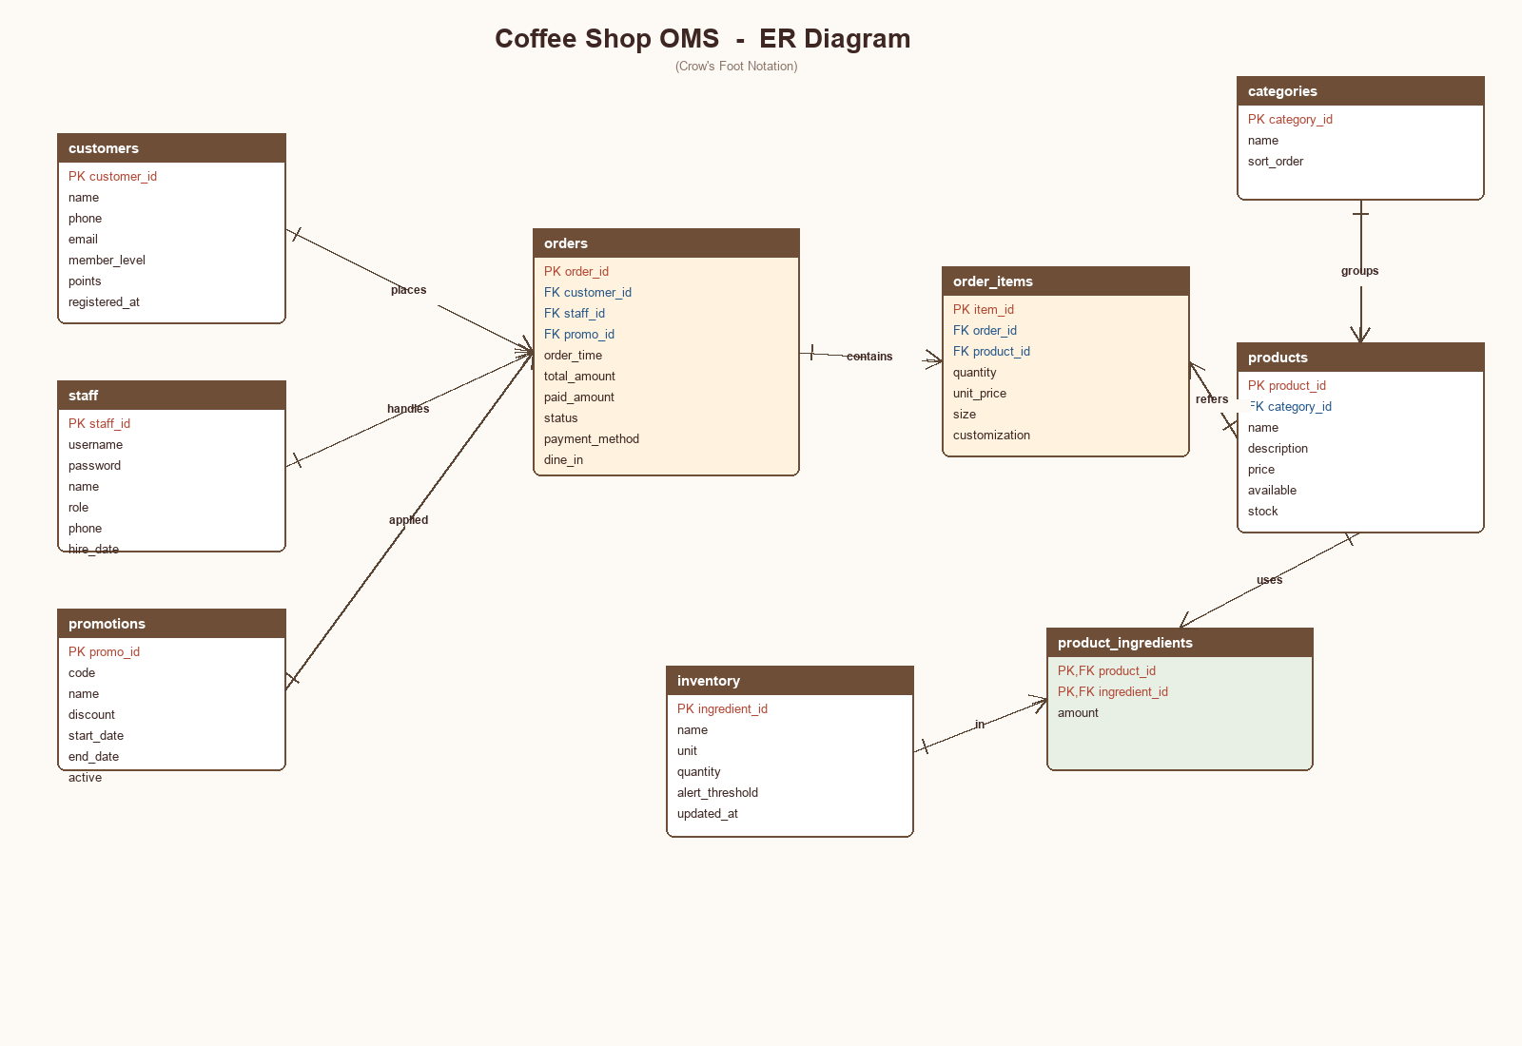
Figure 1. ER Diagram of the Coffee Shop OMS
3.3 Logical design (relations). The conceptual model is mapped to nine relations. Primary keys are underlined in the diagram and marked PK in the schema; foreign keys are marked FK.
- customers (customer_id PK, name, phone, email, member_level, points, registered_at)
- staff (staff_id PK, username, password, name, role, phone, hire_date, active)
- categories (category_id PK, name, sort_order)
- products (product_id PK, category_id FK, name, description, price, available, stock)
- promotions (promo_id PK, code, name, discount, start_date, end_date, active)
- orders (order_id PK, customer_id FK, staff_id FK, promo_id FK, order_time, total_amount, paid_amount, status, payment_method, dine_in, remark)
- order_items (item_id PK, order_id FK, product_id FK, quantity, unit_price, size, customization)
- inventory (ingredient_id PK, name, unit, quantity, alert_threshold, updated_at)
- product_ingredients (product_id PK/FK, ingredient_id PK/FK, amount)
3.4 Physical design (MySQL DDL). The full DDL is provided in sql/schema.sql. Excerpt:
CREATE TABLE orders (
order_id INT AUTO_INCREMENT PRIMARY KEY,
customer_id INT,
staff_id INT NOT NULL,
promo_id INT,
order_time DATETIME DEFAULT CURRENT_TIMESTAMP,
total_amount DECIMAL(10,2) NOT NULL DEFAULT 0,
status ENUM('PENDING','PAID','PREPARING','READY','COMPLETED','CANCELLED'),
payment_method ENUM('CASH','CARD','WECHAT','ALIPAY') DEFAULT 'WECHAT',
dine_in TINYINT(1) DEFAULT 1,
FOREIGN KEY (customer_id) REFERENCES customers(customer_id) ON DELETE SET NULL,
FOREIGN KEY (staff_id) REFERENCES staff(staff_id),
FOREIGN KEY (promo_id) REFERENCES promotions(promo_id) ON DELETE SET NULL,
INDEX idx_time(order_time), INDEX idx_status(status)
) ENGINE=InnoDB;
3.5 Constraints and business rules.
- Primary-key and foreign-key constraints guarantee entity and referential integrity.
- CHECK (quantity > 0) on order_items prevents zero / negative line items.
- ENUM types restrict status, role, payment_method to valid values.
- Unique indexes on customers.phone, staff.username, promotions.code prevent duplicates.
- Index on orders(order_time) and orders(status) accelerates the dashboard and filter queries.
3.6 Database programming. Three triggers and one stored procedure implement business rules inside the database:
-- Trigger 1: recompute order total whenever an item is inserted
CREATE TRIGGER trg_item_after_insert AFTER INSERT ON order_items
FOR EACH ROW
BEGIN
UPDATE orders SET total_amount = (
SELECT COALESCE(SUM(quantity * unit_price),0)
FROM order_items WHERE order_id = NEW.order_id
) WHERE order_id = NEW.order_id;
END;
-- Trigger 2: award loyalty points when an order becomes PAID
CREATE TRIGGER trg_order_after_update AFTER UPDATE ON orders
FOR EACH ROW
BEGIN
IF NEW.status = 'PAID' AND OLD.status <> 'PAID' AND NEW.customer_id IS NOT NULL THEN
UPDATE customers SET points = points + FLOOR(NEW.total_amount)
WHERE customer_id = NEW.customer_id;
END IF;
END;
-- Stored procedure: place a single-item order in one call
CREATE PROCEDURE sp_place_order(IN p_customer INT, IN p_staff INT,
IN p_product INT, IN p_qty INT,
OUT p_order_id INT) ...
3.7 Representative SQL queries used by the application:
-- (a) today's revenue
SELECT SUM(total_amount) FROM orders
WHERE DATE(order_time) = CURDATE() AND status <> 'CANCELLED';
-- (b) top-5 best-selling products
SELECT p.name, SUM(oi.quantity) AS qty
FROM order_items oi JOIN products p ON p.product_id = oi.product_id
GROUP BY p.product_id ORDER BY qty DESC LIMIT 5;
-- (c) ingredients below alert threshold
SELECT name, quantity, alert_threshold FROM inventory
WHERE quantity <= alert_threshold;
-- (d) members ranked by points
SELECT name, member_level, points FROM customers ORDER BY points DESC;
3.8 Sample DML used during testing:
INSERT INTO orders(customer_id, staff_id) VALUES (1, 3);
SET @o := LAST_INSERT_ID();
INSERT INTO order_items(order_id, product_id, quantity, unit_price)
VALUES (@o, 3, 2, 25.00), (@o, 11, 1, 32.00);
UPDATE orders SET status='PAID' WHERE order_id=@o;
-- trg_item_after_insert recomputes total_amount to 82.00
-- trg_order_after_update awards 82 loyalty points to customer 1
4. Brief Instructions for Use
Step 1 - Environment: Python 3.10+, MySQL 8.0+ (or SQLite for a quick demo). Install dependencies with `pip install -r requirements.txt`.
Step 2 - Initialise the database:
mysql -uroot -p < sql/schema.sql
mysql -uroot -p coffee_shop < sql/data.sql
Step 3 - Start the server:
cd src && python app.py # http://127.0.0.1:5000
Step 4 - Log in. Three demo accounts are pre-loaded:
Role | Username | Password
Admin | admin | admin123
Barista | barista | barista123
Cashier | cashier | cashier123
Step 5 - Typical workflow: Cashier opens 'New Order', picks the customer (or 'Walk-in'), adds menu items with size and quantity, chooses payment and submits. The Barista watches the 'Orders' page and updates status to PREPARING / READY / COMPLETED. The Admin manages menu items, inventory and reviews statistics.
5. Main Interface Screenshots
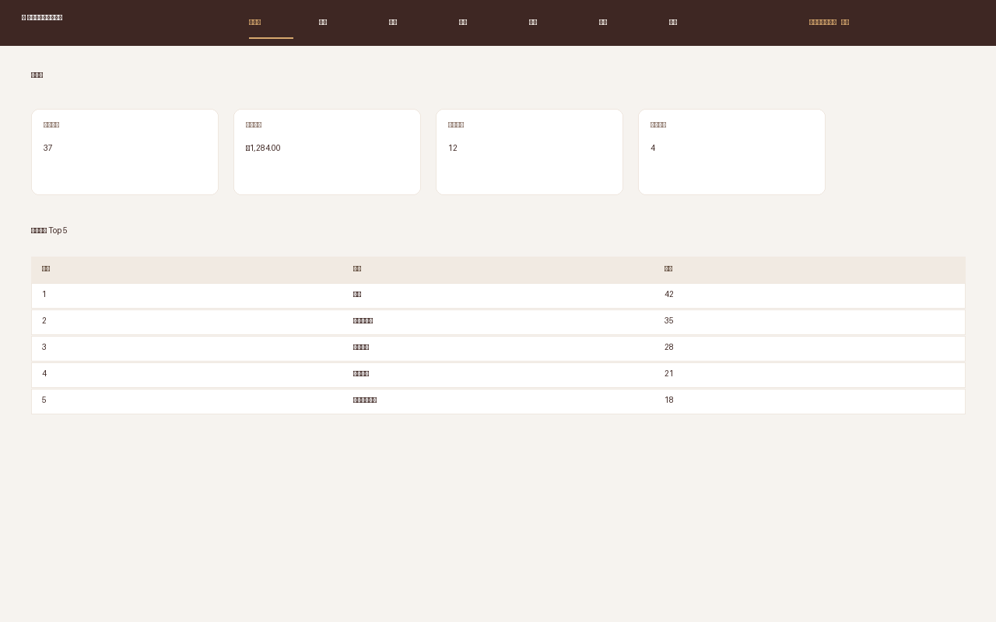
Figure 2. Dashboard - KPI cards and top-5 sellers.
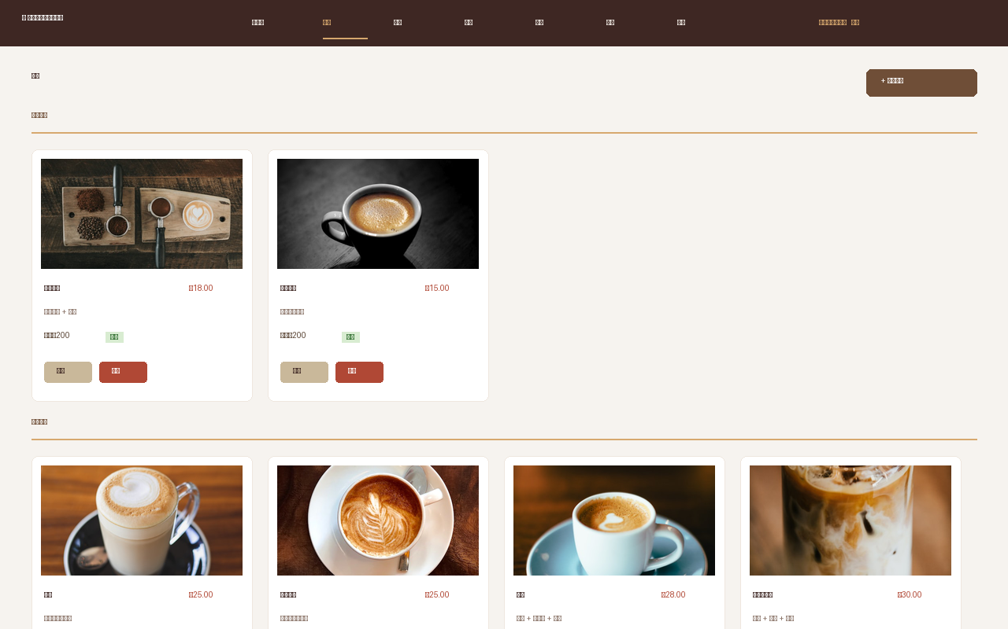
Figure 3. Menu - categorised product cards with admin actions.
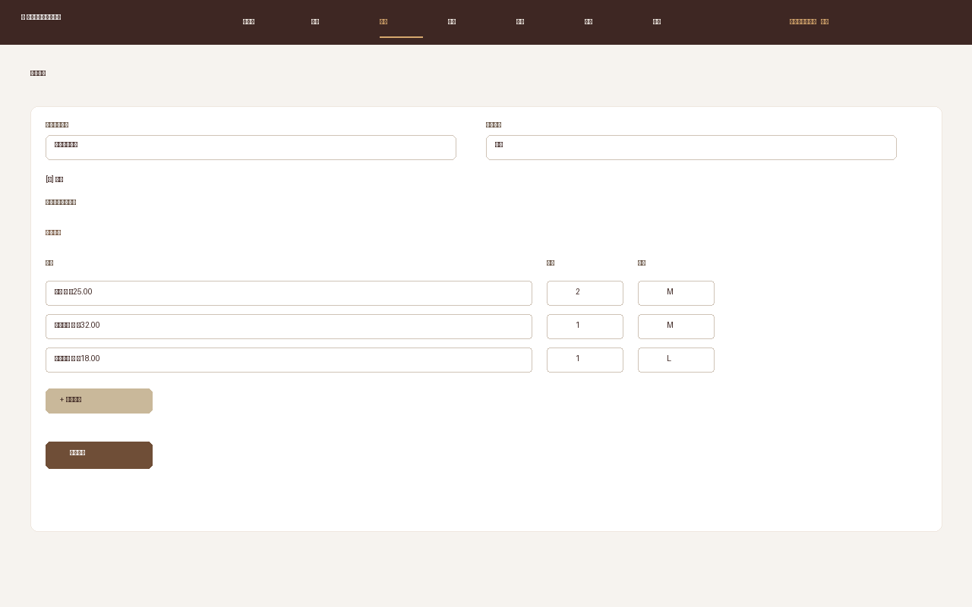
Figure 4. New Order - multi-line cart with size and payment.
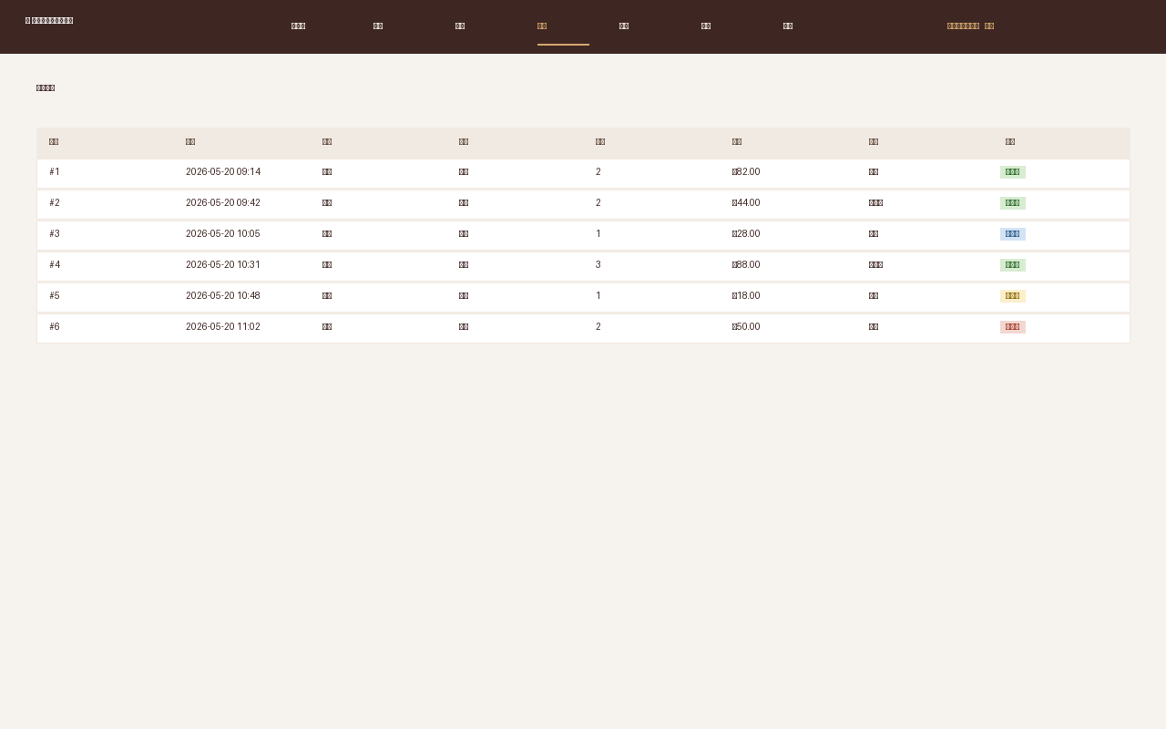
Figure 5. Order list - status filter and color tags.
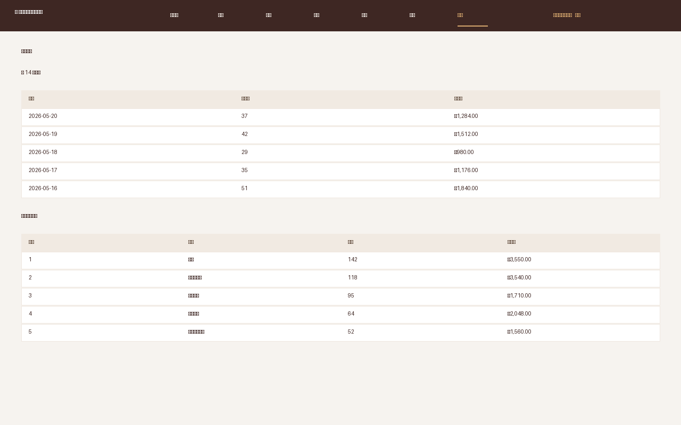
Figure 6. Statistics - daily revenue and product ranking.
6. Summary
This course design delivered a fully working Coffee Shop Order Management System backed by MySQL and a Flask web application. From the database side, the project exercised the entire design lifecycle: requirement analysis, conceptual modelling with an ER diagram, logical mapping to 3NF relations, and physical implementation with DDL/DML, indexes, views, triggers and a stored procedure. From the application side, the system implements role-based authentication, complete CRUD on every entity, a multi-line order cart, an order-status state machine, ingredient inventory with low-stock alerts, and daily / per-product statistics.
Existing problems and future improvements: (1) Passwords are stored in plain text for grading convenience and should be replaced with salted hashes (werkzeug.security or bcrypt) before production use. (2) The system currently runs as a single Flask process; for higher concurrency it should be deployed behind Gunicorn + Nginx. (3) The inventory model only decrements ingredients on demand - an automatic deduction at the moment of payment, plus periodic stock-take reconciliation, would make the inventory module closer to reality. (4) Front-end styling is intentionally lightweight; a richer SPA (Vue / React) could improve UX, especially for the order-taking screen on tablets.
Through this project the author gained hands-on experience in translating a real business scenario into a normalised relational model, in using triggers / stored procedures to keep business invariants close to the data, and in building a complete data-driven web application end to end.
7. References
- [1] Abraham Silberschatz, Henry F. Korth, S. Sudarshan. Database System Concepts (7th Edition). McGraw-Hill, 2019.
- [2] Wang Shan, Sa Shixuan. An Introduction to Database Systems (5th Edition). Higher Education Press, 2014.
- [3] Oracle Corporation. MySQL 8.0 Reference Manual. https://dev.mysql.com/doc/refman/8.0/en/
- [4] Pallets Projects. Flask Documentation (3.x). https://flask.palletsprojects.com/
- [5] Mike Bayer. SQLAlchemy 2.0 Documentation. https://docs.sqlalchemy.org/
- [6] Martin Fowler. Patterns of Enterprise Application Architecture. Addison-Wesley, 2002.

